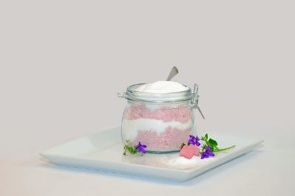

**Welcome To**

**Sugar Throw!**

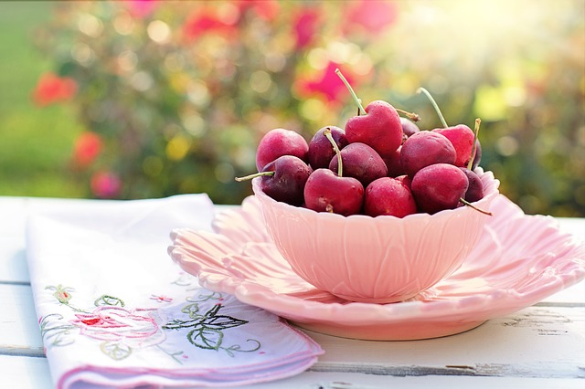





**Welcome To**

**Sugar Throw!**

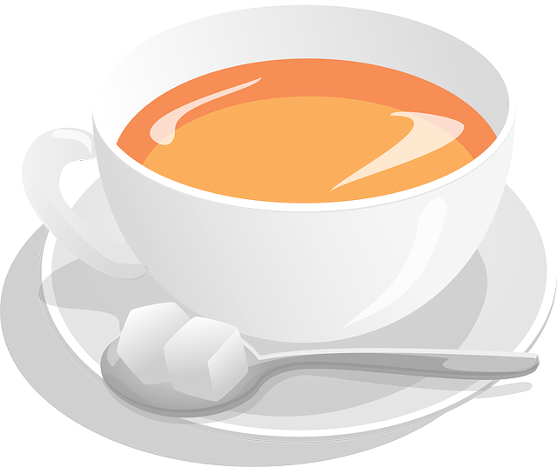

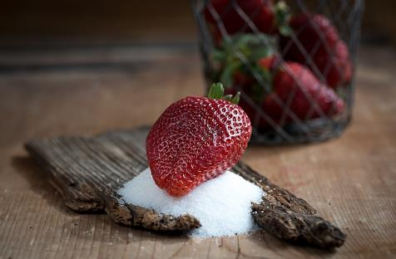

**Tip:**

**If you take sugar in tea or coffee, gradually reduce the amount until you can cut it out altogether, or try swapping to sweeteners instead.**

**Try some new flavours with herbal teas, or make your own with hot water and a slice of lemon or ginger.**

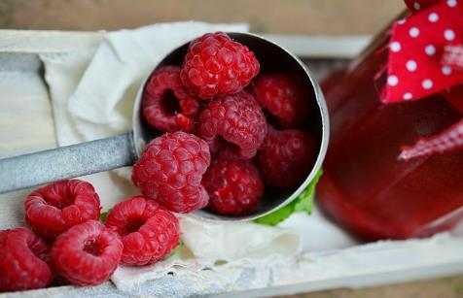

**Set Yourself Goals!**

**Goals can help you achieve your target sugar consumption, and gain you extra points!**

**Go Settings > Goals**



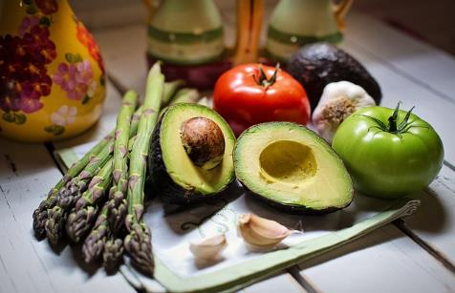

**Set Yourself Goals!**

**Goals can help you achieve your target sugar consumption, and gain you extra points!**

**Go Settings > Goals**